Advanced Engineering Mathematics, by Erwin Kreyszig 10th. Ed.

**Problem Set 9.5**

No.1









 It is an ellipse.

No.2



It is a straight line.

No.3



It is a parabola on yz-plane .

No.4







It is a circle of radius 5 onplane .

No.5









It is an ellipse on xy-plane .

No.6







It is an ellipse on xy-plane .

No.7



It is a circular helix .

No.8









It is a hyperbola on the plane z = 2.

No.9

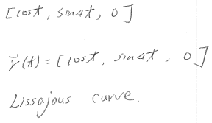

No.10









A hyperbola on the y=2 plane.

No.11



Or 

No.12



Or 

No.13



Or 

No.14



Or 

No.15



Or 

No.16



Or 

No.17



Or 

No.18



Or 

No.19



Or 

No.20

Set

Then 



×2+ 

+×3 



No.21

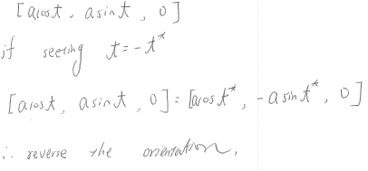

No.22

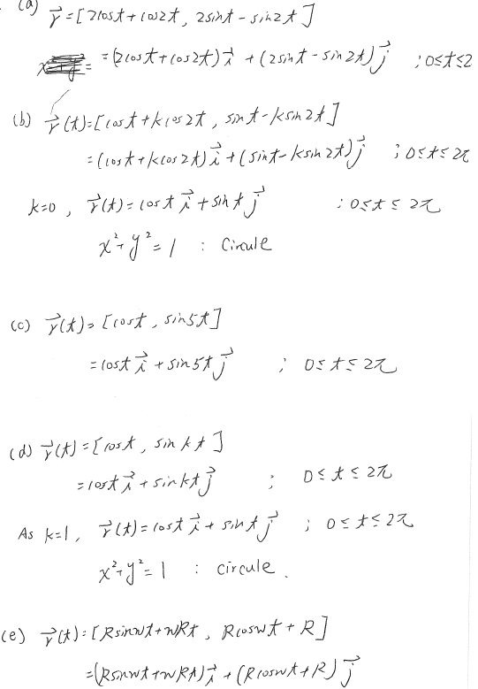

No.23

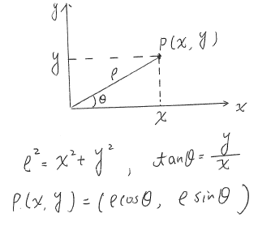

No.24



 

At 



The tangent  

No.25









At  



The tangent  

No.26







At  



The tangent  

No.27







At  



The tangent  

No.28









At  



The tangent  

No.29



 



No.30







Point , Point 



No.31







Point , Point 



No.32















Total length 

No.33











No.34

Polar coordinates 

Derive 





















The cardioid 













No.35

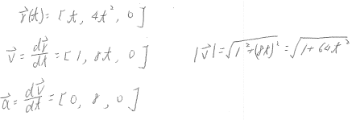

No.36



No.37

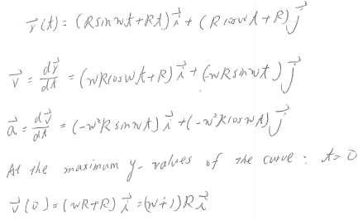

No.38

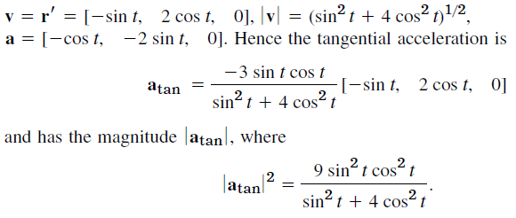

No.39

















No.40



























No.41





















No.42



























No.43

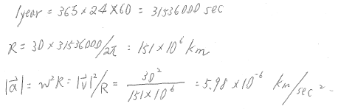

No.44

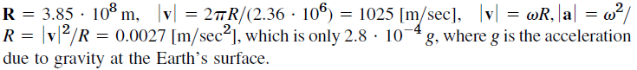

No.45

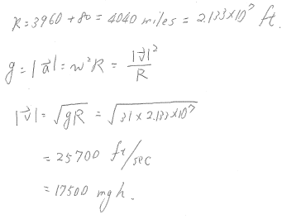

No.46

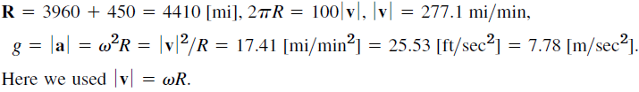

No.47

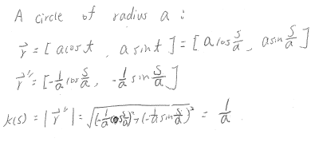

No.48

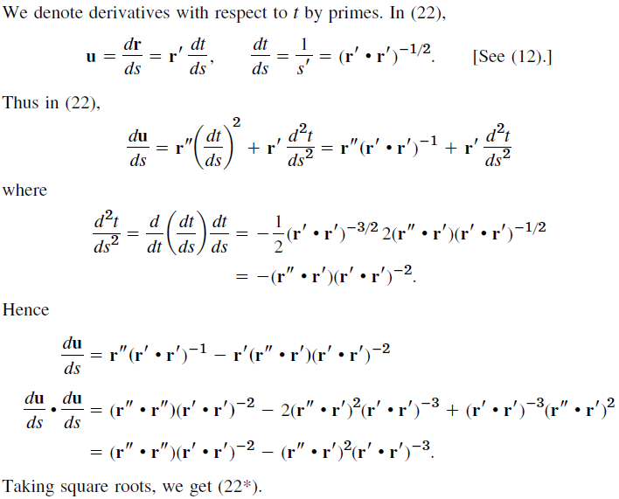

No.49

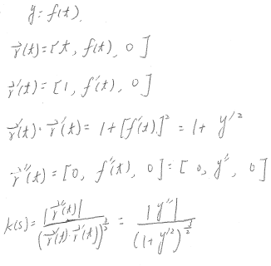

No.50

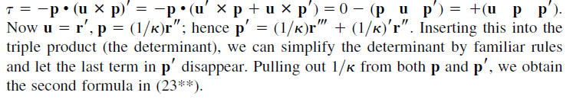

No.51

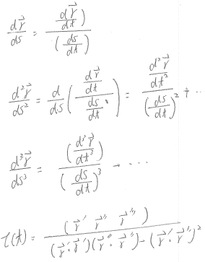

No.52

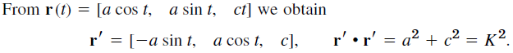

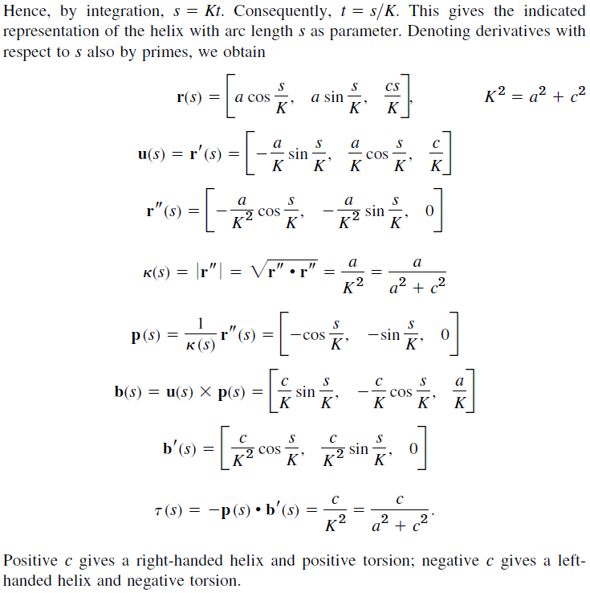

No.53

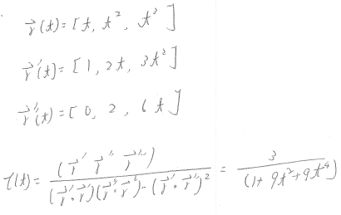

No.54

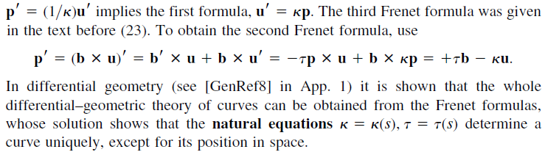

No.55

